PRE-DEFENSE CLEARANCE CHECKLIST
Form 2 | Capstone Project 2 Final Defense
PART I. GROUP INFORMATION
Capstone Project Title | [CAPSTONE PROJECT TITLE]
Proponents | [Surname, First Name M.I.] (Proponent 1)  [Surname, First Name M.I.] (Proponent 2)  [Surname, First Name M.I.] (Proponent 3)  [Surname, First Name M.I.] (Proponent 4)
Year and Section | BSIT 4 ____
Content Adviser | [Name, Degree]
Programming Adviser | [Name, Degree]
Date first submitted to the FIC
Date of resubmission (if any)
PART II. HOW FORM 2 IS USED IN THE FINAL DEFENSE PROCESS
Form 2 is the gate between a finished draft and a scheduled final defense. Your group opens it as soon as the manuscript draft (Form 1) and the system release candidate are ready, and keeps it updated until the Faculty-in-Charge (FIC) signs the clearance in Part IV. No Final Defense Form (Form 4) is processed without a cleared Form 2 attached to it.
Figure 1 on the next page shows each step. Each step has its own color, and the sections of the checklist in Part III carry the color of the step in which they are verified. Boxes with a FORM 2 tag are the points where this form is filled in, initialed, or signed. Table 1 summarizes who does what on the form at each of those points.
Table 1. Form 2 touchpoints
Step | Who | What is done on Form 2 | Part of Form 2
Step 1 | Proponents | Tick the Self-check column for every item you have completed and attach the evidence named in each row. | Part III, all sections
Step 2 | Content Adviser | Mark each item in Section A as Complied or Not Yet and initial, alongside signing Form 3A. | Part III, Section A; Part IV
Step 3 | Programming Adviser | Mark each item in Sections B and C as Complied or Not Yet and initial, alongside signing Form 3B. | Part III, Sections B and C; Part IV
Step 4 | Proponents | Complete Section E after the mock defense and record the actions taken on its recommendations. | Part III, Section E
Step 5 | Faculty-in-Charge (FIC) | Verify Sections D and E and the advisers' marks, then sign Cleared or list the deficiencies for resubmission. | Part III, Sections D and E; Part IV

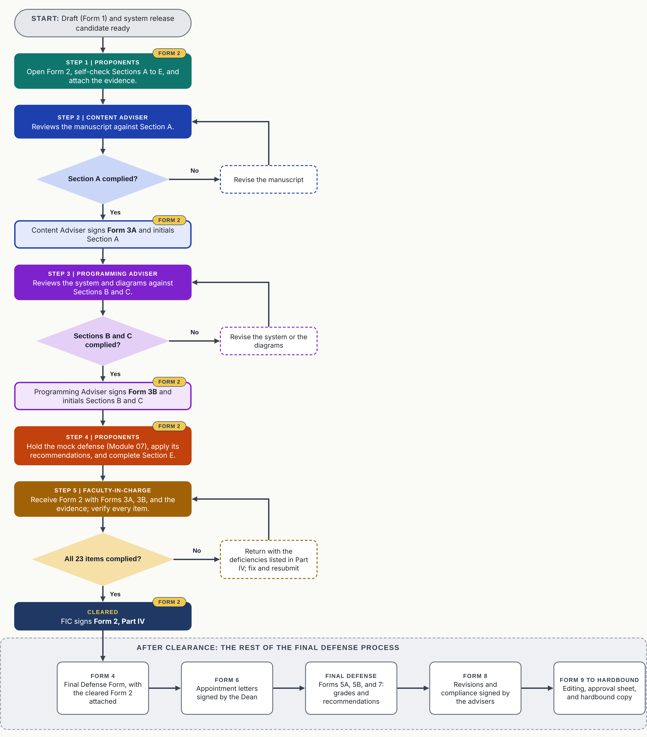
Figure 1. Use of Form 2 along the Final Defense Process. Colors identify the step: teal, Step 1 (proponents); blue, Step 2 (Content Adviser); purple, Step 3 (Programming Adviser); orange, Step 4 (mock defense); gold, Step 5 (Faculty-in-Charge); navy, cleared. FORM 2 tags mark where the form is filled in, initialed, or signed. Dashed boxes are revise-and-resubmit loops.

PART III. CLEARANCE CHECKLIST
Proponents tick the Self-check box only when the requirement is fully done and its evidence is attached. Verifiers mark each item Complied or Not yet. Abbreviations: CA, Content Adviser; PA, Programming Adviser; FIC, Faculty-in-Charge.
Section A. Manuscript (Form 1)
No. | Requirement | Evidence to attach | Self-check | Verified by | Verifier's mark
1 | Chapters I to V are complete and follow the Form 1 template, including the front matter, references, and annexes. | Complete manuscript draft | ☐ | CA | ☐ Complied  ☐ Not yet
2 | All comments of the Content Adviser on the latest draft have been addressed. | Consultation record with the CA | ☐ | CA | ☐ Complied  ☐ Not yet
3 | The Literature Map required by Form 3A is prepared and attached. | Literature Map | ☐ | CA | ☐ Complied  ☐ Not yet
4 | Citations and the reference list follow the style prescribed in the Form 1 template. | Reference list | ☐ | CA | ☐ Complied  ☐ Not yet
5 | A similarity check has been run on the full manuscript, and the index is within the University's allowable threshold of ____%. | Similarity report | ☐ | CA | ☐ Complied  ☐ Not yet
Verifier's initials and date for Section A:
Section B. System
No. | Requirement | Evidence to attach | Self-check | Verified by | Verifier's mark
6 | All planned modules are developed, integrated, and working as specified in the approved design (release candidate). | Live demonstration | ☐ | PA | ☐ Complied  ☐ Not yet
7 | Revisions after testing are documented, and the revision log is up to date. | Revision log | ☐ | PA | ☐ Complied  ☐ Not yet
8 | The test plan is executed: at least 90% of test cases pass, and all critical defects are logged and resolved. | Test Plan and Test Results Report | ☐ | PA | ☐ Complied  ☐ Not yet
9 | User Acceptance Testing is done and signed off by the client or end-users. | UAT Sign-off Form | ☐ | PA | ☐ Complied  ☐ Not yet
10 | The system is deployed or pilot-tested in its intended environment, and the client or end-user acceptance is signed. | Deployment Report; Client/End-User Acceptance Form or MOA | ☐ | PA | ☐ Complied  ☐ Not yet
11 | The user manual or guide is complete, and the source code is in the team's version-control repository and accessible to the PA. | User manual; repository link | ☐ | PA | ☐ Complied  ☐ Not yet
Verifier's initials and date for Section B:
Section C. Diagram Annexes (required by Form 3B)
No. | Requirement | Evidence to attach | Self-check | Verified by | Verifier's mark
12 | Context Diagram, presented using the standard model. | Annex | ☐ | PA | ☐ Complied  ☐ Not yet
13 | Data Flow Diagram in Gane and Sarson notation, down to Level 2. | Annex | ☐ | PA | ☐ Complied  ☐ Not yet
14 | Use Case Diagram showing the interactions among actors, use cases, and the system. | Annex | ☐ | PA | ☐ Complied  ☐ Not yet
15 | Entity-Relationship Diagram or Database Diagram that supports the needs of the developed system. | Annex | ☐ | PA | ☐ Complied  ☐ Not yet
Verifier's initials and date for Section C:
Section D. Advising and Endorsements
No. | Requirement | Evidence to attach | Self-check | Verified by | Verifier's mark
16 | Consultation record with the Content Adviser, with at least ____ signed sessions. | Consultation record | ☐ | FIC | ☐ Complied  ☐ Not yet
17 | Consultation record with the Programming Adviser, with at least ____ signed sessions. | Consultation record | ☐ | FIC | ☐ Complied  ☐ Not yet
18 | Form 3A is signed by the Content Adviser, with all 16 items ticked. | Form 3A (original) | ☐ | FIC | ☐ Complied  ☐ Not yet
19 | Form 3B is signed by the Programming Adviser, with all 6 items ticked and the four diagram annexes attached. | Form 3B (original) | ☐ | FIC | ☐ Complied  ☐ Not yet
Verifier's initials and date for Section D:
Section E. Defense Readiness (Module 07)
No. | Requirement | Evidence to attach | Self-check | Verified by | Verifier's mark
20 | The mock or practice defense has been held and evaluated. | Mock Defense Evaluation | ☐ | FIC | ☐ Complied  ☐ Not yet
21 | Every recommendation from the mock defense has been acted upon. | List of actions taken | ☐ | FIC | ☐ Complied  ☐ Not yet
22 | The final presentation slides and the live demonstration script are ready, with a backup copy of the system and slides. | Slides; demo script | ☐ | FIC | ☐ Complied  ☐ Not yet
23 | Complete manuscript copies are ready for the three panelists and the two advisers. | Copies for 5 recipients | ☐ | FIC | ☐ Complied  ☐ Not yet
Verifier's initials and date for Section E:

PART IV. CERTIFICATION AND CLEARANCE
A. Proponents' Certification
We certify that every item we ticked in Part III is complete and that all attached evidence is authentic.
[Group Leader]  Group Leader, for the Proponents | Date
B. Verification by the Advisers
Verifier | Sections verified | Signature over printed name | Date
Content Adviser | A
Programming Adviser | B and C
C. Clearance Decision (Faculty-in-Charge)
☐ CLEARED. The group may file Form 4 (Final Defense Form) with a copy of this cleared Form 2 attached.
☐ NOT YET CLEARED. Complete the items listed below and resubmit Form 2 on or before: ______________________
Item No. | Deficiency and action required
FELIX R. PENETRANTE, MIS
Faculty-in-Charge, IT 124 | Date: ____________

